Soukhna Wade

Week 5 DSC640

5.3 Assignment: Create Optimal Hotel Recommendations

**Case study from the Predictive Analytics:** Employee retention

**Dataset:** HR analytic predict employee retention

**Overview**

Employee retention is an effort by a business to maintain a working environment that supports current employees to remain with the company. Employee retention should be a top priority for any organization's survival. Organizations whose employee engagement scores trend up over time have better employee retention rates**.** Employees are the valuable assets of any organization. But if they quit jobs unexpectedly, it may incur huge cost to the company. For instance, significant expenses include cost of hiring, onboarding, and long-term loss of productivity. Satisfaction Level, average monthly hours, promotion of last 5 years and compensation can be used as variables to predict employees’ retentions in my model.

**Business Understanding**

Managing and retaining stuffs is core to protect any organization. Employees' retention policies are aimed to address the needs of employees to enhance their job satisfaction and reduce the substantial costs involved in hiring and training new staff. Policies, benefits should be implemented to increase job satisfaction, and reduce employee attrition are for all businesses. The goal of an employee retention program is to have productive and happy employees who want to stay with your company long term.

**Data Understanding**

The following lines show you a model, which will predict employee retention rate based on HR analytics dataset obtained from Kaggle website. Satisfaction level, average monthly hours, promotion of last 5 years and salary are used as variables to predict employees’ retentions in this model. There are 14,999 rows or observations (obs.) and 10 columns( variables)



**Data Preparation**

Data exploration and visualization

The data analysis shows the following variables as dependent variables in our model:

* Satisfaction Level
* Average Monthly Hours
* Promotion Last 5 Years
* Salary

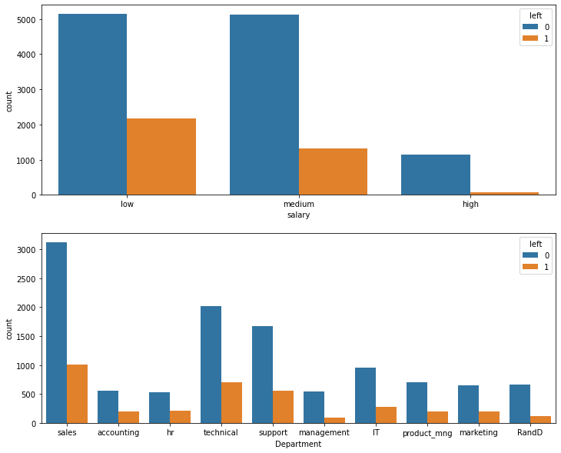

**References:**

The Power to Predict Who Will Click, Buy, Lie, or Die book.

Applied Predictive Analytics which starts on page 377.

Source: <https://www.kaggle.com/gummulasrikanth/hr-employee-retention>